# Literature Review 1

# Point cloud localization and mapping.

# Introduction

Point cloud localization and mapping is a process that uses point cloud inputs from a sensor to calculate a vehicle's position and orientation, while simultaneously mapping the environment.

These sensors may be cameras or laser sensors.

This localization and mapping done simultaneously is called SLAM (simultaneous localization and mapping). It is a method used for autonomous vehicles that lets you build a map and localize your vehicle in that map at the same time. It’s algorithms allow vehicle to map out unknown environments. It is used to carry out tasks such as path planning and obstacle avoidance.

# Main Body

Some key points about point cloud localization and mapping:

Localization: It determines and locates position of the object with respect to the environment.

Mapping: It helps to create an accurate representation of the environment.

Applications: It is used in robotics and autonomous driving to help vehicles and robots find their current position, construct maps, and plan paths.

Sensors: A stereo-camera can be used to take measurements and find depth or distance of obstacle from body. A stereo-camera is however expensive and so two mono-cameras can be used to create a stereo-camera and find accurate results. However, laser sensor point cloud provides high-precision distance measurements and works effectively for map construction with SLAM algorithms. Movement is estimated sequentially registering the point clouds. The calculated movement (travelled distance) is used for localizing the vehicle.

Simultaneous localizing and mapping (SLAM) had been the subject of technical research for many years. But with vast improvements in computer processing speed and the availability of low-cost sensors such as cameras and laser range finders, SLAM algorithms are now used for practical applications in a growing number of fields.

Benefit of SLAM: Let’s take an example of a home robot vacuum cleaning the floor. Without SLAM, it will just move randomly within a room and may not be able to clean the entire floor surface. In addition, this approach uses excessive power, so the battery will run out more quickly. On the other hand, robots with a SLAM algorithm can use information such as the number of wheel revolutions and data from cameras and other imaging sensors to determine the amount of movement needed. This is called localization. The robot can also simultaneously use the camera and other sensors to create a map of the obstacles in its surroundings and avoid cleaning the same area twice. This is called mapping.

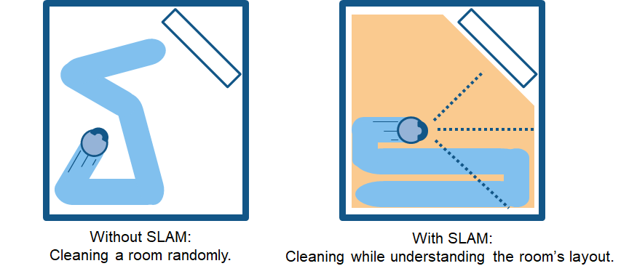

There are two types of technology components used to achieve SLAM. The first type is sensor signal processing, including the front-end processing, which is largely dependent on the sensors used. The second type is pose-graph optimization, including the back-end processing, which is sensor-agnostic.

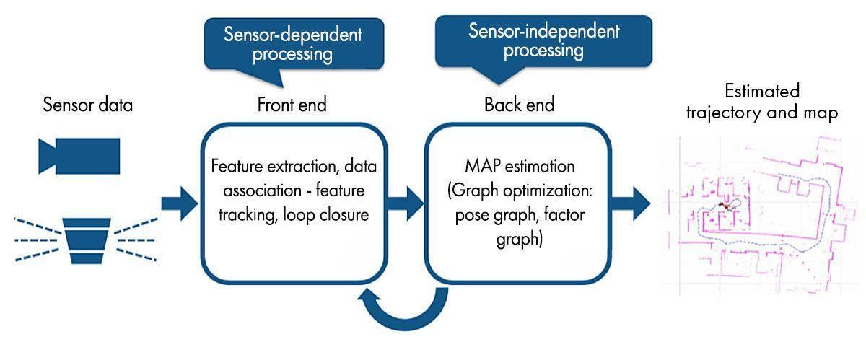

Types of SLAM methods:

Visual SLAM: Visual SLAM uses images acquired from cameras and other image sensors. Visual SLAM can be implemented at low cost with relatively inexpensive cameras. In addition, since cameras provide a large volume of information, they can be used to detect landmarks (previously measured positions). Landmark detection can also be combined with graph-based optimization, achieving flexibility in SLAM implementation.

Lidar SLAM: Light detection and ranging (lidar) is a method that primarily uses a laser sensor to determine accurate distance between obstacle and body. Compared to cameras, lasers are significantly more precise and are used for applications with high-speed moving vehicles such as self-driving cars and drones. It works effectively for map construction with SLAM algorithms. Movement is estimated sequentially registering the point clouds. The calculated movement (travelled distance) is used for localizing the vehicle.

Multi-sensor SLAM: Multi-sensor SLAM is a type of SLAM algorithm that utilizes a variety of sensors to enhance the precision and robustness of SLAM algorithms. By using the complementary strengths of different sensors and mitigating their individual limitations, multi-sensor SLAM can achieve superior performance.

# Conclusion

SLAM is the most efficient way to localize and map the body with respect to the environment. But it is only efficient if it is used effectively.

Although SLAM algorithms are used for some practical applications, several technical challenges prevent more general-purpose adoption. But there are counter measures which should be kept in mind to avoid these challenges.

Some common challenges are:

Localization error: SLAM algorithms estimate sequential movement, which includes some margin of error. The error accumulates over time, causing substantial deviation from actual values. One solution is to remember some characteristics from a previously visited place as a landmark and minimize the localization error. Pose graphs are constructed to help correct the errors. By solving error minimization as an optimization problem, more accurate map data can be generated. This kind of optimization is called bundle adjustment in visual SLAM.

Localization fails and position of map is lost: Image and point-cloud mapping does not consider the characteristics of a robot’s movement. In some cases, this approach can generate discontinuous position estimates. One countermeasure to this is by remembering a landmark as a key frame from a previously visited place.

High computational cost: Although after making such an autonomous system, cost for image processing, point cloud processing and optimization is too high. One solution is to run different processes in parallel.  Using multicore CPUs for processing, single instruction multiple data calculation, and embedded GPUs can further improve speeds in some cases.

Ayush Kakadiya

--------------------------------------------------------------------------------------------